

Quote for Services
29/01/18
Client | Anne Tixier
Contact | ph 027 504 8639 tixieran@gmail.com
Worksite address | 101 Hazlewood Ave, Karori
Billing address | tixieran@gmail.com

See diagram | Work description: | Price
1 | Trim and top the hedge along the side of the property in the area indicated on the diagram below | $60 + gst  Includes all labour, materials, disposal and any other incidental costs
2 | Clean out the garden leaving only the lavenders | $20 + gst  Includes all labour, materials, disposal and any other incidental costs
3 | Take out the rose and the hydrangea at the corner of the house in the area indicated (leave the other hydrangeas) | $30 + gst  Includes all labour, materials, disposal and any other incidental costs
4 | Cut to ground level and remove all the broom, blackberry and other scrub on the bank at the back of the house | $360 + gst  Includes all labour, materials, disposal and any other incidental costs
5 | Cut to ground level and remove the ivy-covered cabbage tree; clear all the ivy off the little tree fern; clear the ivy off the house and cut it back and away from the house | $150 + gst  Includes all labour, materials, disposal and any other incidental costs
 | Travel | n/c
 | Sub-total | $620.00
 | Gst | $ 93.00
 | Total | $713.00

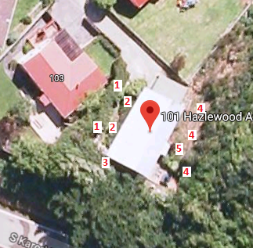

NB:
- ASAP Section Clearing Ltd carries $2M public liability insurance in the unlikely event of damage to property in the execution of our work.

Thank you for the opportunity to quote for this work. If you need clarification of any of the points above please feel free to contact me at any time.

Yours sincerely,

Grant Price
Director
ASAP Section Clearing Ltd
Email: grant@asapsectionclearing.co.nz
Ph 476 8453 / 027-321 8906

